Heaven’s light is our guide



RAJSHAHI UNIVERSITY OF ENGINEERING & TECHNOLOGY
Department of Mechatronics Engineering

Lab Report
Experiment No.: 08
Experiment Name: 1Hz Signal Generation using Atmega32 (Timer0) with Proteus Simulation.

Submitted By: | Submitted To:
Samia Afsana  ID: 2008055  3rd Year, Odd Semester  Department of Mechatronics Engineering  Rajshahi University of Engineering & Technology, Rajshahi-6204. | Md Mehedi Hasan  Assistant Professor  Department of Mechatronics Engineering  Rajshahi University of Engineering & Technology, Rajshahi-6204.
Md. Sakib Hassan Chowdhury
Lecturer
Department of Mechatronics Engineering
Rajshahi University of Engineering & Technology, Rajshahi-6204.

Date of Experiment: 1st June, 2024
Date of Submission: 29th June, 2024

MTE 3104
Microcontroller and Interfacing Sessional

Experiment No.: 08

Experiment Name: 1Hz Signal Generation using Atmega32 (Timer0) with Proteus Simulation.

Objectives:

- To configure the Atmega32 microcontroller for generating a 1Hz signal using Timer0.
- To simulate the 1Hz signal generation using Proteus software.
- To understand the process of setting up Timer0 on the Atmega32.
- To verify the accuracy and stability of the generated 1Hz signal through simulation.
- To demonstrate the practical application of microcontroller timers in signal generation.

Theory:
Timers are integral peripherals in microcontrollers used for counting and timing applications. The Atmega32 microcontroller features several timers, including Timer0, an 8-bit timer. The timer can be configured to operate in various modes, such as Normal, CTC (Clear Timer on Compare Match), Fast PWM, and Phase Correct PWM. To generate a 1Hz signal, the CTC mode of Timer0 can be used. In CTC mode, the timer counter (TCNT0) counts from 0 to a specified value stored in the Output Compare Register (OCR0). When the counter matches the OCR0 value, it resets to 0 and an interrupt can be triggered.
In AVR ATmega16 / ATmega32, there are three timers:
- Timer0: 8-bit timer
- Timer1: 16-bit timer
- Timer2: 8-bit timer
Basic registers and flags of the Timers:
TCNTn (Timer / Counter Register): Every timer has a timer/counter register. It is zero upon reset. It counts up with each clock pulse.
TOVn (Timer Overflow Flag): Each timer has a Timer Overflow flag. When the timer overflows, this flag will get set.
TCCRn (Timer Counter Control Register): This register is used for setting the modes of timer/counter.
OCRn (Output Compare Register): The value in this register is compared with the content of the TCNTn register. When they are equal, the OCFn flag will get set.

Timer0:
TCNT0 (Timer / Counter Register 0): It is an 8-bit register. It counts up with each pulse.
TCCR0 (Timer / Counter Control register 0): This is an 8-bit register used for the operation mode and the clock source selection [1].
Timer0 Overflow
Normal mode: When the counter overflows i.e. goes from 0xFF to 0x00, the TOV0 flag is set.

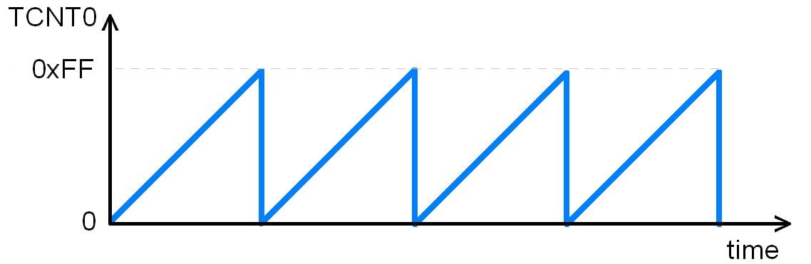
Figure- 8.1: Timer0 Overflow [2].

In this experiment, the aim is to be generated a 1Hz signal using the Atmega32 microcontroller and its Timer0 module, simulated in the Proteus environment. The goal is to understand the working of timers in microcontrollers and to demonstrate how to configure them to achieve specific timing tasks.

Working Principle:

- The code set was set all of PORTC's pins to output and initialized Timer0 to cause an interrupt upon overflow.
- Timer0 was set up to run in Normal Mode with a 64-bit prescaler and enabled global interrupts.
- After that, the main program was into an endless loop.
- The ISR (Interrupt Service Routine) was triggered when Timer0 overflows, increasing the value of the ovf count variable.
- Toggling the value of PORTC was occured when ovf_count reached 61, or around one second with a prescaler of 64. To resume counting after toggling, ovf count is reset to 0.

- System Clock (F_CPU): 1 MHz
- Prescaler: 64(Assume)

- The timer clock frequency is_

$$TCF=\frac{F (CPU)}{Prescaler}$$

So, for a 1MHz system clock with 64 prescaler.

$$TCF=\frac{1000000}{64}=15625 Hz$$

- The period of one timer tick (the time it takes for the timer to increment by one) is the Timer Tick Period.
$$TTP=\frac{1 }{15625}=64×{10}^{-6} sec$$

- As this timer0 has 8 bits the timer counts from 0 to 255, it overflows every 256 counts.

$$Overflow Period=256×\left(64×{10}^{-6} \right)=16.384×{10}^{-3} sec$$

- Thus, the timer overflows approximately every 16.384*10^-3 sec with a prescaler of 64. Now to generate a 1Hz signal, here need an interrupt to occur every 1 sec. Since each overflow occurs every 16.384*10^-3 sec.

$$Number of Overflows= \frac{1}{16.384×{10}^{-3}}=61$$

Approximately 61 overflows are required to achieve 1 sec. Thus, by counting the number of overflows, a pin is toggled to generate a 1 Hz signal.

Required Components:

- Atmega32 Microcontroller.
- Push button.
- LED
- Resistors

Code:

#include <avr/io.h>
#include <avr/interrupt.h>

volatile uint8_t ovf_count=0;
int main(void)
{
DDRC=0xFF;
TIMSK |= 0x01;
TCNT0= 0;
TCCR0= 0x03;
//enable global interrupt(bit7 of SREG)
sei();
while (1)
{
}
}

//Timer0 overflow interrupt service routine
ISR(TIMER0_OVF_vect)
{
ovf_count= ovf_count + 1;

//61 required to get 1 sec
if(ovf_count == 61)
{
PORTC ^= 0xFF;
//reset counter
ovf_count = 0;
}
}

Figures:

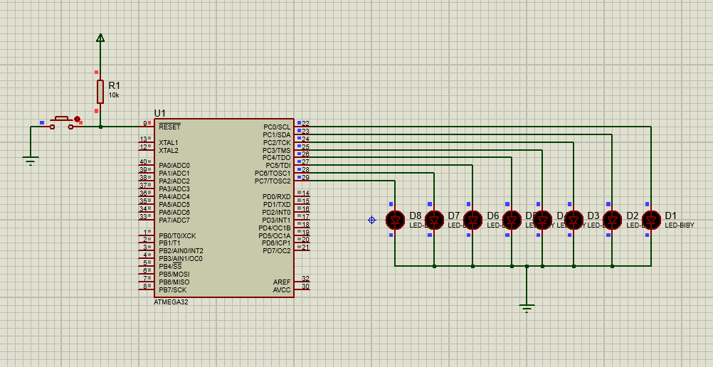

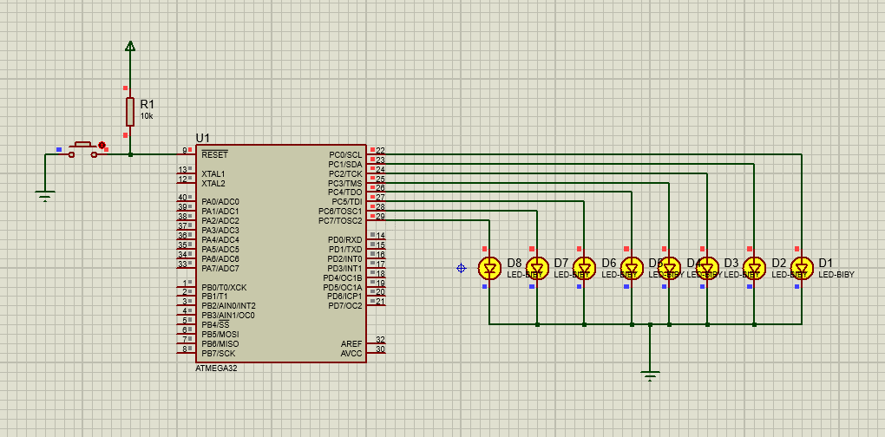

Figure-8.2: 1 Hz signal generation by LEDs

Discussion:
In the Proteus simulation with the ATmega32 microcontroller, generating a 1 Hz signal involved setting Timer0 to either toggle an output pin or trigger an interrupt at that frequency. Timer0 was configured to generate an interrupt or toggle an output pin to produce a 1 Hz signal when it reached a predetermined count based on the prescaler and desired frequency. During this process, the LED began turning on repeatedly even before the button was pressed, which became problematic.

Practical Uses:
- Clock Generation: Used in digital watches, clocks, and timers.
- Periodic Interrupts: Useful in scheduling tasks in real-time systems.
- Waveform Generation: Essential in communication systems for signal modulation.
- Frequency Measurement: Timers can measure the frequency of external signals.

Conclusion:
The experiment successfully demonstrated the generation of a 1Hz signal using the Atmega32 microcontroller's Timer0. Through careful configuration of the timer registers and the use of interrupts, precise timing control was achieved. This exercise underscored the importance of timers in embedded systems for generating accurate time delays and periodic signals. The Proteus simulation validated the theoretical calculations and provided a visual confirmation of the 1Hz signal, illustrating the practical applications and benefits of using simulation tools in embedded system development.

References:

[1] Timer0 [Online]. Available:
https://www.electronicwings.com/avr-atmega/atmega1632-timer (2024)

[2] Timer0 Overflow [Online]. Available:
https://www.electronicwings.com/storage/PlatformSection/TopicContent/55/description/timer%20value.png (Accessed: 24th June, 2024)

